MA4605 Lecture 5A

|  |
| --- |
| Robust regression is an alternative to ordinary least squares regression (OLS , the type of regression we have studied thus far) when data is contaminated with outliers or influential . |

**Some important terms in linear regression.**

***Residual:*** The difference between the fitted value ( a predicted value based on the regression equation) and the actual, observed value.

***Outlier:***  In linear regression, an outlier is an observation with large residual.  In other words, it is an observation whose dependent-variable value is unusual given its value on the predictor variables.  An outlier may indicate a sample peculiarity or may indicate a data entry error or other problem.

***Leverage:***  An observation with an extreme value on a predictor variable is a point with high leverage.  Leverage is a measure of how far an independent variable deviates from its mean.  High leverage points can have a great amount of effect on the estimate of regression coefficients.

***Influence:***  An observation is said to be influential if removing the observation substantially changes the estimate of the regression coefficients.  Influence can be thought of as the product of leverage and *outlierness*.

***Cook's distance (or Cook's D):*** A measure that combines the information of leverage and residual of the observation.

|  |
| --- |
| FitAll = lm(Taste ~ Acetic + H2S + Lactic)  plot(FitAll) |

This will produce a set of four plots: residuals versus fitted values, a Q-Q plot of standardized residuals, a scale-location plot (square roots of standardized residuals versus fitted values, and a plot of residuals versus leverage that adds bands corresponding to Cook's distances of 0.5 and 1.

Using the plot to get a detailed interpretation of how well the model fits is beyond the scope of this module. However it is worth noting that plots identify particular observations that may warrant re-examination.

|  |
| --- |
| ***Remarks :***  The plots actually indicate the fitted model is actually quite good.  The trend lines in the first and third plots demonstrate constant variance, and in the case of the first, the trend line through the centre of the plot follows the X=0 line quite well.  The Q-Q plot (i.e. the second plot) indicates that the assumption of normality is vindicated.  The last plot indicates the no observations have unusually high Cook’s Distances values. No observations are beyond the 0.5 (red line) threshold. |

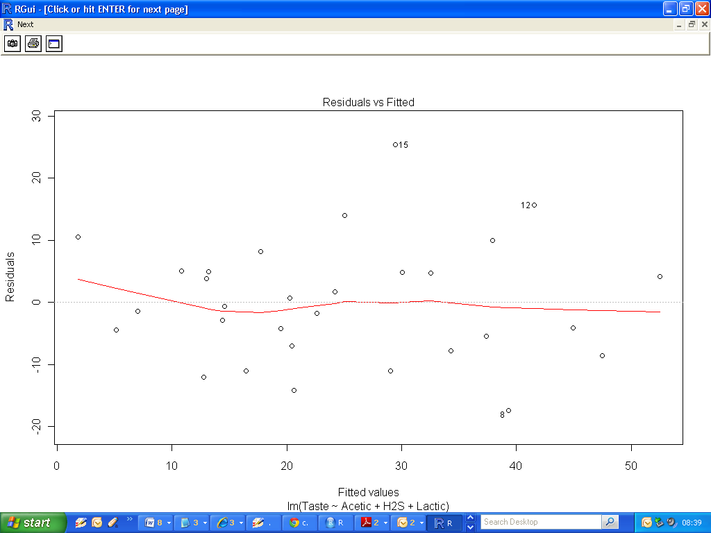

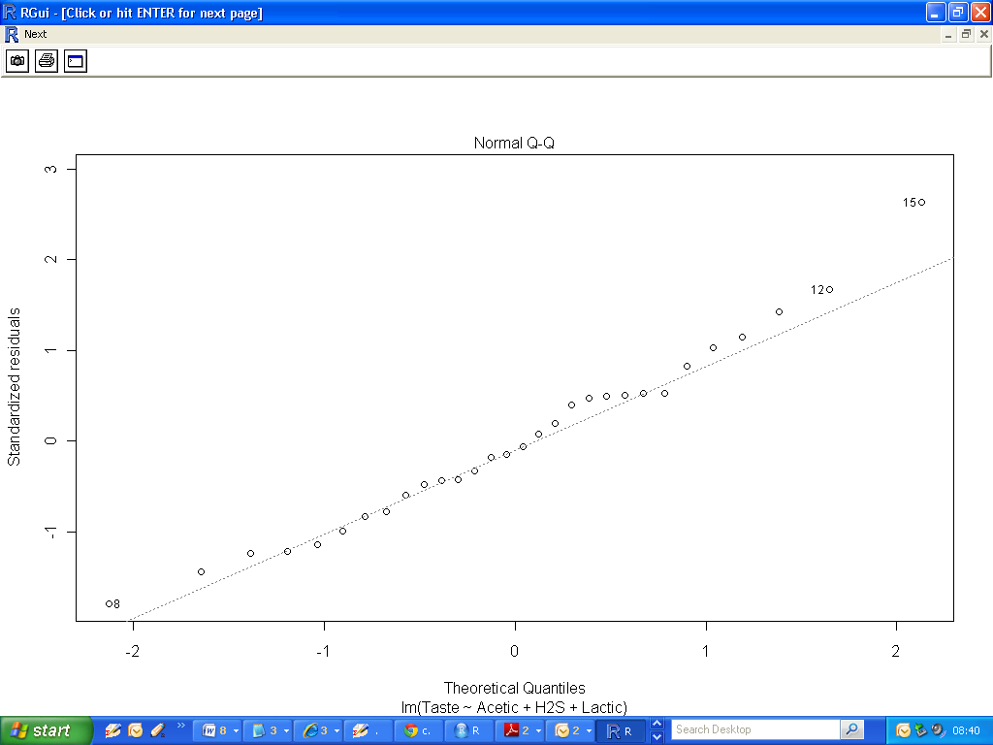

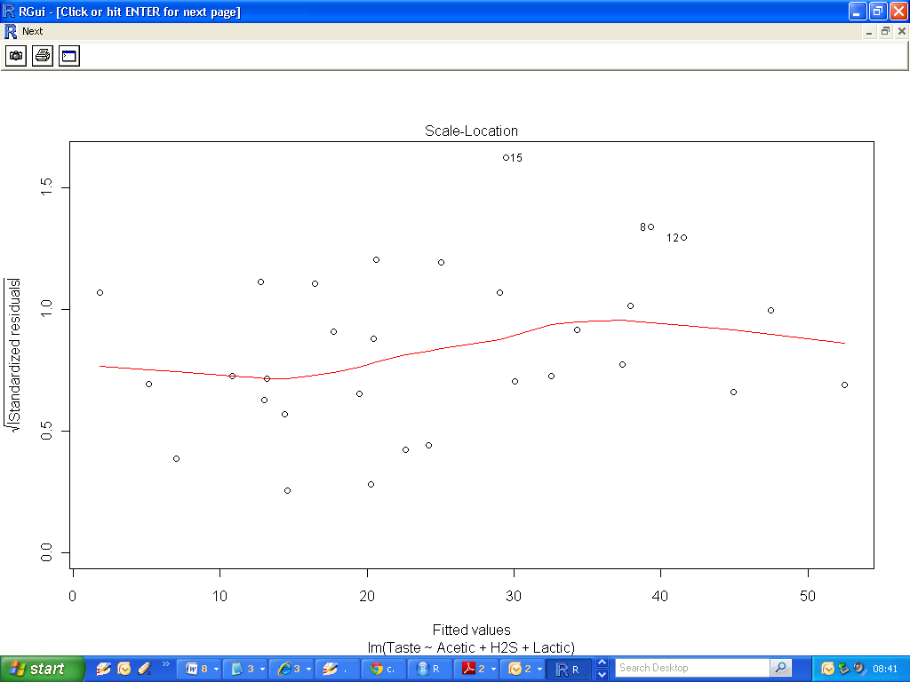

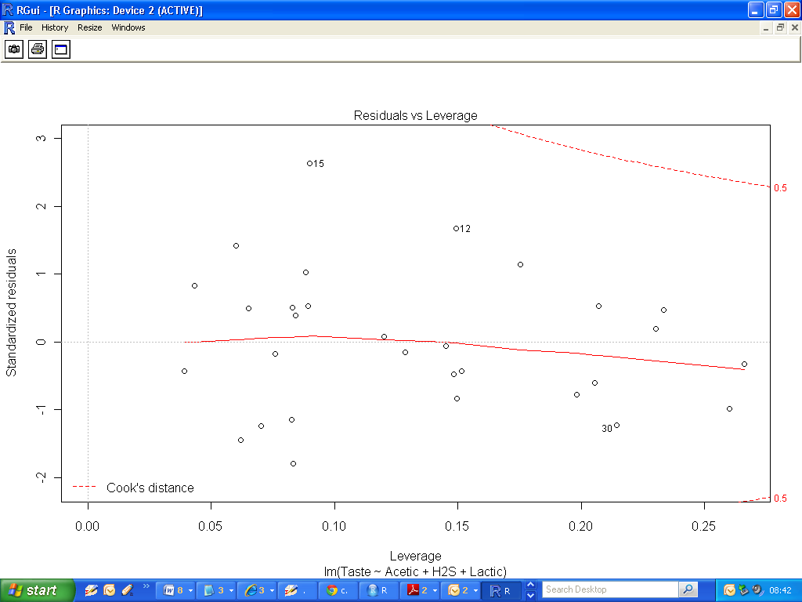

Additionally I have added a line plot of the Cook’s Distance values.

Which observations have the highest values for Cook’s Distance?

|  |
| --- |
| plot(cooks.distance(FitAll),type="b", pch=18,col="red") |

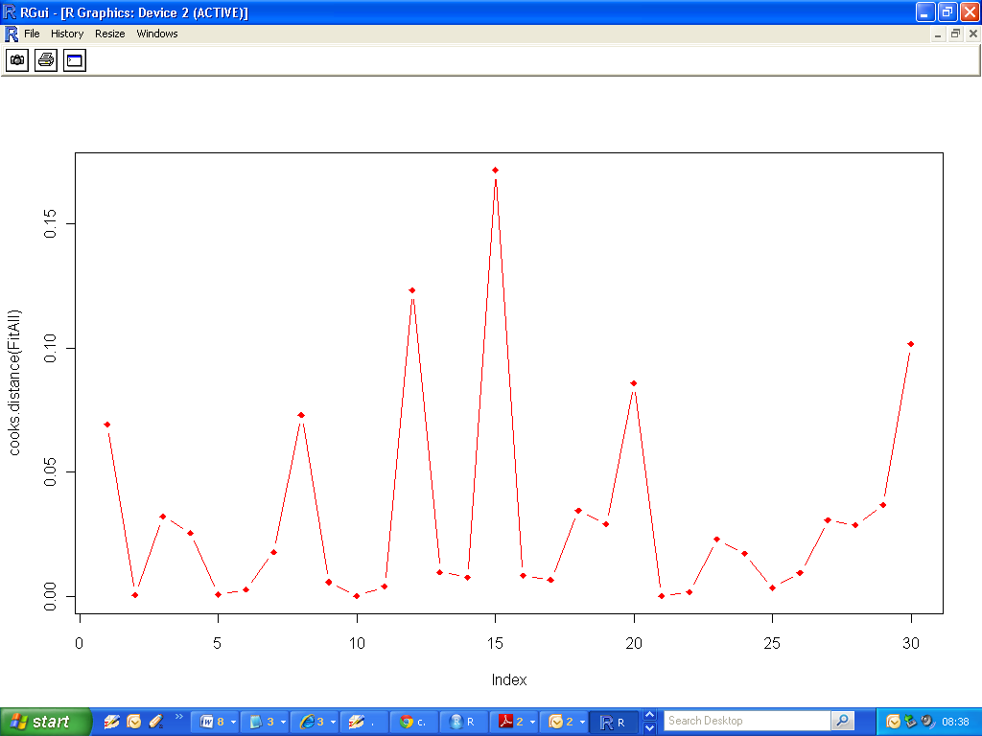

To counterpoint the diagnostic plots, we will look at some from a “bad “ fitted model.

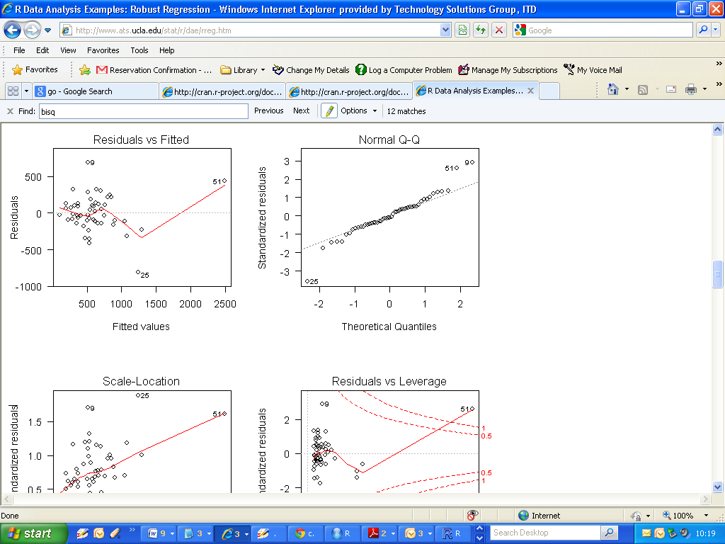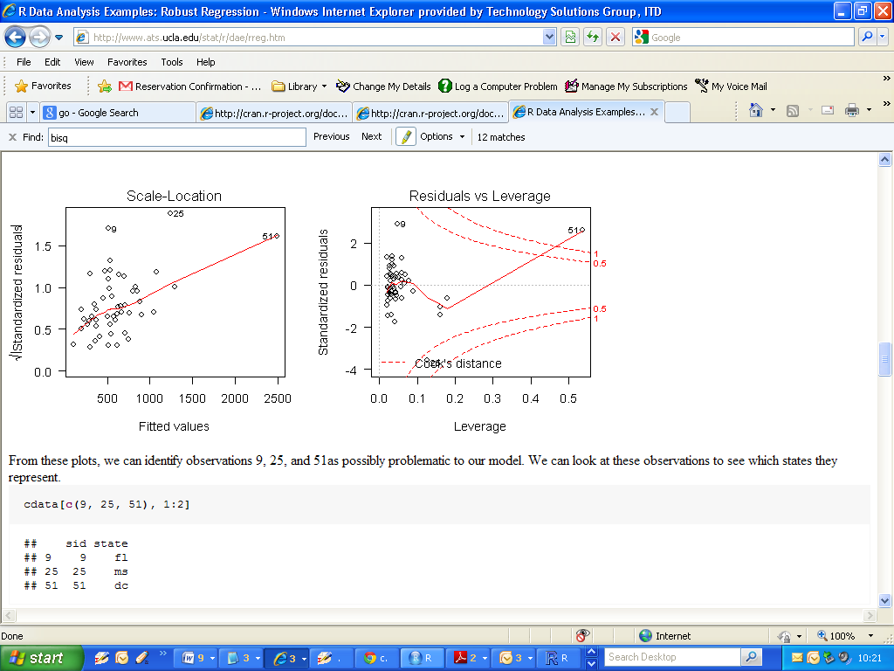

**Implementation of Robust Regression**

When fitting a least squares regression, we might find some outliers or high leverage data points.  We have decided that these data points are not data entry errors, neither they are from a different population than most of our data. So we have no proper reason to exclude them from the analysis.

Robust regression might be a good strategy since it is a compromise between excluding these points entirely from the analysis and including all the data points and treating all them equally in OLS regression. The idea of robust regression is to weigh the observations differently based on how well behaved these observations are.

The idea of robust regression is to weigh the observations differently based on how well behaved these observations are. Roughly speaking, it is a form of weighted and reweighted least squares regression (i.e. a two step process , first fitting a linear model, then a robust model to correct for the influence of outliers).

Robust regression is done by ***iterated re-weighted least squares*** (IRLS). The rlm command in the ***MASS*** package command implements several versions of robust regression.

There are several weighting functions that can be used for IRLS. We are going to first use the ***Huber weights*** in this example. We will then look at the final weights created by the IRLS process. This can be very useful.

Also we will look at an alternative weighting approach to Huber’s weighting – called ***Bisquare weighting.***

In Huber weighting, observations with small residuals get a weight of 1 and the larger the residual, the smaller the weight. This is defined by the weight function

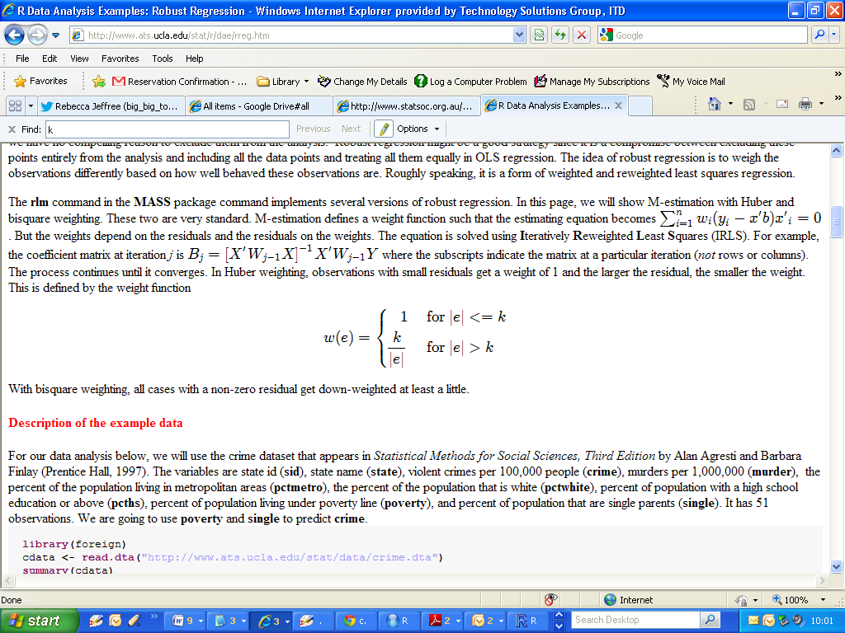

**(VERY IMPORTANT)**

The value ***k*** for the Huber method is called a ***tuning constant***; smaller values of ***k*** produce more resistance to outliers, but at the expense of lower efficiency when the errors are normally distributed.

The tuning constant is generally picked to give reasonably high efficiency in the normal case; in particular, ***k = 1.345σ*** for the Huber’s method, where σ is the standard deviation of the errors) produce 95-percent efficiency when the errors are normal, and still offer protection against outliers.

(*Bisquare Weighting is very similar*).

|  |
| --- |
| > library(MASS)  > FitAll.rr = rlm(Taste ~ Acetic + H2S + Lactic)  >  > summary(FitAll.rr)  Call: rlm(formula = Taste ~ Acetic + H2S + Lactic)  Residuals:  Min 1Q Median 3Q Max  -16.163 -5.612 -1.153 5.487 27.106  Coefficients:  Value Std. Error t value  (Intercept) -20.7529 20.1001 -1.0325  Acetic -1.5331 4.5422 -0.3375  H2S 4.0515 1.2715 3.1864  Lactic 20.1459 8.7885 2.2923  Residual standard error: 8.471 on 26 degrees of freedom |

***Regression Equation:***

***Taste* = -20.75 -1.53 Acetic + 4.05 H2S + 20.14 Lactic***

From before, we noticed that observations 15 , 12 and 8 were influential in the determination of the coefficients. The following table indicates the weight given to each observation when using robust regression.

We can see that roughly, as the absolute residual goes down, the weight goes up. In other words, cases with a large residuals tend to be down-weighted.

(You do not need to know how to implement the code used to generate this table, but we will be looking at how to construct data frames later in the course.)

|  |
| --- |
| > hweights <- data.frame(Taste = Taste,  resid = FitAll.rr$resid,  weight = FitAll.rr$w)  > hweights2 <- hweights[order(FitAll.rr$w), ]  >  >  > hweights2[1:15, ]  Taste resid weight  15 54.9 27.105636 0.4203556  12 57.2 17.518919 0.6504044  8 21.9 -16.162753 0.7049043  3 39.0 14.318512 0.7957592  18 6.4 -13.609277 0.8371707  28 0.7 -11.410452 0.9985018  1 12.3 9.990965 1.0000000  2 20.9 -1.692664 1.0000000  4 47.9 10.648009 1.0000000  5 5.6 -1.866642 1.0000000  6 25.9 2.632602 1.0000000  7 37.3 5.744433 1.0000000  9 18.1 4.775657 1.0000000  10 21.0 1.048052 1.0000000  11 34.9 5.723592 1.0000000 |

Implementing with bisquare weighting simply requires the specification of the additional argument, as per the code below, highlighted in green)

|  |
| --- |
| > FitAll.rr.2 = rlm(Taste ~ Acetic + H2S + Lactic, psi = psi.bisquare)  > summary(FitAll.rr.2)  Call: rlm(formula = Taste ~ Acetic + H2S + Lactic, psi = psi.bisquare)  Residuals:  Min 1Q Median 3Q Max  -15.7034 -5.1552 -0.9793 5.6933 27.7661  Coefficients:  Value Std. Error t value  (Intercept) -17.7730 20.7031 -0.8585  Acetic -2.2650 4.6784 -0.4841  H2S 4.0569 1.3096 3.0977  Lactic 20.6885 9.0522 2.2855  Residual standard error: 7.878 on 26 degrees of freedom |

***Regression Equation :***

***Taste* = -17.77 -2.26 Acetic + 4.05 H2S + 20.68 Lactic***

Weights using Bisquare estimator.

|  |
| --- |
| > hweights2[1:15, ]  Taste resid weight  15 54.9 27.766087 0.1884633  12 57.2 18.182810 0.5735669  8 21.9 -15.703388 0.6707319  3 39.0 14.384429 0.7193235  18 6.4 -13.462286 0.7516310  28 0.7 -11.190438 0.8246092  19 18.0 -11.112316 0.8269297  4 47.9 10.860173 0.8343637  1 12.3 9.852297 0.8625704  20 38.9 -8.952091 0.8858015  14 25.9 8.588121 0.8946576  30 5.5 -8.019522 0.9078077  7 37.3 6.329446 0.9420556  11 34.9 5.999726 0.9478611  13 0.7 -5.470990 0.9565447 |

* We can see that the weight given to some observations is dramatically lower using the bisquare weighting function than the Huber weighting function and the coefficient estimates from these two different weighting methods differ.
* When comparing the results of a regular OLS regression and a robust regression, if the results are very different, you will most likely want to use the results from the robust regression.
* Large differences suggest that the model parameters are being highly influenced by outliers.
* Different functions have advantages and drawbacks: Huber weights can have difficulties with severe outliers, and bisquare weights can have difficulties converging or may yield multiple solutions.